**Project Design Phase-II**

**Data Flow Diagram & User Stories**

|  |  |
| --- | --- |
| Date | 26-06-2025 |
| Team ID | LTVIP2025TMID59656 |
| Project Name | Enchanted Wings: Marvels of Butterfly Species |
| Maximum Marks | 4 Marks |

**Data Flow Diagrams:**

**A Data Flow Diagram (DFD)** illustrates how data moves within the butterfly classification system. It outlines interactions between users (researchers, students, citizens), the image classification model, and storage components.

**Example: DFD Level 0 (Context Diagram)**

* **Users (Researchers / Citizens / Students)** → Upload butterfly image
* **System** → Processes image using pre-trained CNN
* **Classification Result** → Shown to user + saved in the dataset
* **Educational Module** → Returns species info, ecological insights
* **Admin Panel** → Manages dataset, monitors model accuracy

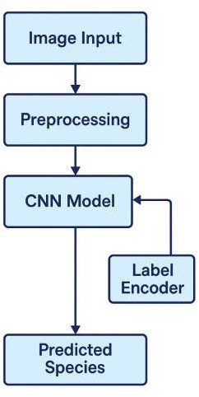

**User Stories**

**User Story Table – Enchanted Wings: Marvels of Butterfly Species**

|  |  |  |  |  |  |
| --- | --- | --- | --- | --- | --- |
| **User Type** | **Functional Requirement (Epic)** | **User Story / Task** | **Acceptance Criteria** | **Priority** | **Release** |
| **Researcher**   |  | | --- | |  | | |  | | --- | | Butterfly Classification | | As a researcher, I can upload butterfly images and receive accurate species names | Image is classified with ≥90% accuracy | High | Sprint-1 |
| |  | | --- | | **Researcher** |  |  | | --- | |  | | |  | | --- | | Data Visualization |  |  | | --- | |  | | |  |  |  | | --- | --- | --- | | |  | | --- | | As a researcher, I can view regional distribution and classification statistics |  |  | | --- | |  | | | |  | | --- | | Visual charts and data summaries are generated |  |  | | --- | |  | | Medium | Sprint-2 |
| **Citizen** | Educational Interface | As a citizen, I can learn about a butterfly species after uploading an image | Educational content is displayed post-classification | Medium | Sprint-2 |
| **Admin** | |  | | --- | |  |  |  | | --- | | Database Manage | | As an admin, I can add or remove images and edit labels in the dataset | Changes are reflected immediately in model input | High | Sprint-1 |
| **Client** | Mobile Interaction | As a user, I can classify butterflies via my phone camera in the field | Real-time classification is returned under 2 seconds | High | Sprint-2 |
| **Student** | |  | | --- | |  |  |  | | --- | | Species Exploration | | As a student, I can view common species by region with pictures and names | Interactive gallery loads with categorized species | Medium | Sprint-2 |
| **Admin** | Model Monitoring | As an admin, I can view model accuracy, confusion matrix, and retraining logs. | Stats update dynamically and retraining history available. | Medium | Sprint-3 |